**ABSTRACT**

Blockchain technology, first introduced with the cryptocurrency Bitcoin, has grown into a transformative force across various sectors, particularly in the management of digital assets. Digital assets, which include cryptocurrencies, tokens, non-fungible tokens (NFTs), and stablecoins, are digital representations of value that can be traded, transferred, and stored electronically. This project investigates the application of blockchain technology in enhancing the security, transparency, and efficiency of digital asset transactions**.**

The study begins with an introduction to blockchain technology and digital assets, providing foundational knowledge on these concepts. A comprehensive literature review then examines existing research and case studies, highlighting the benefits and challenges associated with blockchain and digital assets.

Data analysis and interpretation are conducted using both graphs and pi-charts, providing a detailed examination of how blockchain technology impacts the management and transaction of digital assets.

The findings of the study reveal significant advantages of blockchain in the realm of digital assets, including enhanced security through cryptographic techniques, increased transparency via decentralized ledgers, and improved transaction efficiency by eliminating intermediaries. The project concludes with a discussion of these findings, their implications for future research, and potential developments in the blockchain and digital asset landscape.

**INTRODUCTION**

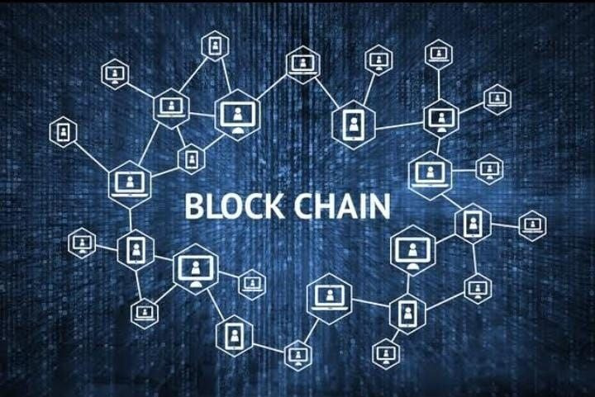

**Blockchain Technology:**

Blockchain technology is a way of recording information that makes it difficult or impossible to change, hack, or cheat the system. Imagine it as a digital ledger of transactions that is duplicated and distributed across the entire network of computer systems on the blockchain. Each block in the chain contains several transactions, and every time a new transaction occurs on the blockchain, a record of that transaction is added to every participant’s ledger.

This decentralized database is managed by multiple participants, known as nodes, making it highly secure and transparent. Blockchain was first introduced with Bitcoin, the pioneering cryptocurrency, by an anonymous person or group known as Satoshi Nakamoto in 2008.

**Key Features of Blockchain Technology**

**Decentralization**: Unlike traditional databases controlled by a single entity, blockchain’s decentralized nature means it’s spread across multiple computers. This makes it robust against failures and attacks.

**Transparency**: All transactions on a blockchain are visible to everyone in the network. This transparency builds trust because participants can verify transactions themselves.

**Security**: Blockchain uses advanced cryptographic methods to secure data. Once a block is added to the chain, it is virtually impossible to alter it without altering all subsequent blocks, which would require network consensus.

**Consensus Mechanisms**: To validate transactions and add new blocks to the blockchain, the network uses consensus mechanisms like Proof of Work (Pow) or Proof of Stake (POS). These mechanisms ensure that all participants agree on the validity of transactions.

**Smart Contracts**: These are self-executing contracts with the terms of the agreement directly written into code. Smart contracts automatically enforce and execute the terms when predefined conditions are met.

**How Blockchain Works**

•**Transactions**: A user initiates a transaction, which is then broadcast to the network.

•**Block Creation**: Transactions are grouped into a block by network nodes.

•**Validation**: The block is validated through a consensus mechanism, ensuring its legitimacy.

•**Chain Addition**: Once validated, the block is added to the blockchain, linked to the previous block.

•**Distribution**: The updated blockchain is distributed across all nodes, ensuring each node has the latest version.

**SMART CONTRACTS**

**Definition:**

Smart contracts are self-executing contracts with the terms of the agreement directly written into code. They run on blockchain platforms, ensuring that once the conditions specified in the contract are met, the contract is automatically executed without the need for intermediaries.

**How They Work:**

**1.Code and Conditions:** A smart contract is coded with specific rules and conditions that need to be met for the contract to be executed. These conditions are typically written in a programming language like Solidity (for Ethereum) or Rust (for Polka Dot).

**2.Deployment:** Once coded, the smart contract is deployed on a blockchain network. Ethereum is the most widely used platform for deploying smart contracts, but other blockchains like Biance Smart Chain, Polka dot, and Solana also support them.

**3.Execution:** When the predefined conditions are met, the smart contract automatically executes the agreed-upon actions. This could include transferring funds, registering ownership, or any other action defined in the contract.

**4.Immutability:** After deployment, the smart contract code cannot be altered. This ensures trust and security as the terms of the contract are transparent and unchangeable.

**Key Characteristics:**

1.**Automation:** Smart contracts eliminate the need for intermediaries by automating the execution of contract terms. This reduces costs and speeds up processes.

2.**Transparency:** All parties involved in a smart contract can view the terms and conditions, ensuring transparency and trust.

3.**Security:** The immutability and cryptographic security of blockchain technology protect smart contracts from tampering and unauthorized access.

4.**Efficiency:** By automating processes and reducing the need for intermediaries, smart contracts can significantly increase efficiency and reduce the time required for transactions.

**Applications of Smart Contracts:**

**Finance:-Decentralized Finance (DeFi):** Smart contracts are the ackbone of DeFi applications, enabling automated lending, borrowing, and trading without traditional banks.

**Insurance:** Smart contracts can automate claims processing, ensuring that claims are paid out automatically when specific conditions are met.

**Supply Chain Management:**

**-Tracking and Transparency:** Smart contracts can be used to track the movement of goods through the supply chain, ensuring transparency and reducing fraud.

**-Automated Payments:** Payments can be automatically released when goods reach specific checkpoints in the supply chain.

**Real Estate:**

**-Property Transactions:** Smart contracts can automate the process of transferring property ownership, reducing the need for intermediaries and paperwork.

**-Rental Agreements:** Rental payments can be automated, and terms enforced through smart contracts, ensuring timely payments and adherence to rental condition

**Healthcare:**

**-Patient Records**: Smart contracts can ensure secure and transparent management patient records, with access granted only to authorized individuals.

**-Automated Claims:** Healthcare claims can be processed automatically based on predefined conditions, reducing administrative overhead.

**Legal Agreements:**

**-Wills and Trusts:** Smart contracts can automate the execution of wills and trusts, ensuring that assets are distributed according to the specified terms upon the occurrence of certain events.

**-Business Contracts:** Business agreements can be executed automatically when predefined conditions are met, reducing the need for legal intermediaries.

Smart contracts represent a transformative innovation, providing automated transparent, and secure solutions across various industries. Their ability to

execute agreements without intermediaries offers significant potential for efficiency gains and cost savings

**Digital Assets**

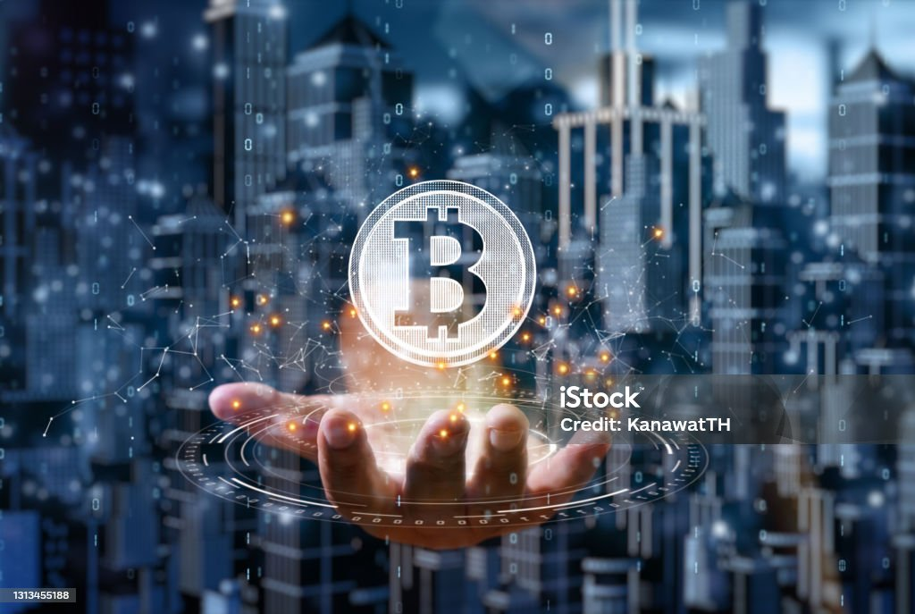

**What are Digital Assets**

Digital assets are anything of value that exists in digital form and can be traded, transferred, or stored electronically. Thanks to blockchain technology, digital assets have become secure, transparent, and efficient. They include cryptocurrencies, tokens, non-fungible tokens (NFTs), and stablecoins.

**Types of Digital Assets**

1.**Cryptocurrencies**: These are digital currencies like Bitcoin and Ethereum that use cryptography for security and operate on decentralized networks, enabling peer-to-peer transactions without intermediaries.

2 **Tokens**: These are digital assets created on existing blockchain platforms like Ethereum. They can represent a variety of things:

•**Utility Tokens**: Used to access a product or service within a blockchain ecosystem.

•**Security Tokens**: Represent ownership in a real-world asset, like stocks or real estate, and are regulated by securities laws.

• **Governance Tokens**: Give holders voting rights within a blockchain project.

3.**Non-Fungible Tokens (NFTs)**: These unique digital assets represent ownership of specific items like digital art or collectibles. Each NFT is distinct and cannot be exchanged on a one-to-one basis with another NFT.

4.**Stablecoins**: These are cryptocurrencies designed to have a stable value by being pegged to a reserve asset like the US dollar or gold. Examples include Tether (USDT) and USD Coin (USDC).

**Benefits of Digital Assets**

**Efficiency**: Transactions are faster and more efficient, as they eliminate the need for intermediaries.

• **Security**: Blockchain technology ensures the security of digital assets through cryptographic techniques and immutable records.

• **Accessibility**: Digital assets can be accessed and transferred globally, promoting financial inclusion.

•**Transparency**: Every transaction is recorded on the blockchain, providing a clear and traceable history.

**Use of Blockchain Technology in Digital Assets**

**How Blockchain Supports Digital Assets:**

Blockchain technology is the backbone of digital assets, providing a secure and transparent platform for their creation, management, and transfer. Its decentralized nature eliminates intermediaries, reduces costs, and increases transaction speed and efficiency. The immutable and transparent nature of blockchain ensures the security and traceability of digital assets, building trust among users.

**Applications of Blockchain in Digital Assets:**

1.**Cryptocurrencies**: Blockchain enables the creation and transfer of cryptocurrencies, allowing decentralized and peer-to-peer transactions. Bitcoin and Ethereum are prime examples of cryptocurrencies that use blockchain technology.

2.**Tokenization**: Blockchain allows for the creation of tokens representing various assets. This process, known as tokenization, makes it easier to trade and manage assets like real estate or stocks.

3.**Smart Contracts**: These self-executing contracts facilitate secure and automatic transactions of digital assets, reducing the need for intermediaries and increasing efficiency.

4.**Non-Fungible Tokens (NFTs)**: Blockchain provides the platform for NFTs, which represent ownership of unique digital items like art or virtual real estate. Platforms like Open Sea and Rarible facilitate the creation and trading of NFTs.

5.**Decentralized Finance (DeFi)**: DeFi platforms use blockchain to offer financial services like lending, borrowing, and trading without traditional banks. They rely on digital assets and smart contracts to provide transparent and accessible financial services.

**Benefits of Using Blockchain for Digital Assets**

•**Security**: Cryptographic techniques and immutable records on the blockchain secure digital assets.

•**Transparency**: Blockchain records every transaction, providing a transparent and auditable history.

•**Efficiency**: Eliminating intermediaries reduces transaction costs and speeds up processes.

•**Accessibility**: Blockchain allows for global access and transfer of digital assets, promoting financial inclusion.

**Challenges and Future Directions:**

•**Scalability**: As blockchain networks grow, they face challenges in handling a large number of transactions efficiently. Solutions to improve scalability are being developed.

•**Regulatory Issues**: The regulatory landscape for digital assets is still evolving, with different approaches in different regions. Clear and consistent regulations are needed to support innovation while protecting consumers.

•**Interoperability**: Different blockchains often operate independently, limiting seamless transfer of assets across platforms. Efforts are underway to improve interoperability.

•**Adoption**: While blockchain and digital assets offer significant benefits, widespread adoption is still in progress. Increasing awareness and education can help drive greater acceptance and use.

**White Papers in Cryptocurrency**

A white paper in the context of cryptocurrencies and blockchain technology serves as a foundational document that outlines the technical details, features, and objectives of a project. Here’s an explanation of what a white paper is and its significance:

1. **Definition:** A white paper is a comprehensive document authored by the creators or developers of a cryptocurrency or blockchain project. It details the problem the project aims to solve, its proposed solution, technical specifications, token economics (if applicable), and the project’s roadmap for development and implementation.

2. **Purpose:**

- Technical Explanation: It provides a technical explanation of how the project utilizes blockchain technology, consensus mechanisms, cryptography, and any other innovative features.

- Vision and Goals: It outlines the project’s vision, goals, and objectives, addressing why the project is needed and how it intends to disrupt or improve upon existing systems or technologies.

- Tokenomics : For projects issuing a native token, the white paper typically explains the tokenomics—how tokens are distributed, their utility within the ecosystem, and any mechanisms for token issuance, burning, or governance.

- Roadmap: It includes a roadmap detailing the project’s timeline for development milestones, platform launches, partnerships, and future plans.

3. **Audienc**e: White papers are primarily targeted at technical stakeholders, potential investors, developers, and anyone interested in understanding the project’s technical and economic underpinnings.

4. **Importance**: - Transparency: White papers enhance transparency by providing detailed insights into the project’s technology, governance, and tokenomics.

- Credibility: A well-written white paper establishes credibility and trust among the community, investors, and stakeholders.

- Educational Resource It serves as an educational resource, helping readers understand the project’s value proposition, technical implementation, and potential impact.

- Transparency: White papers enhance transparency by providing detailed insights into the project’s technology, governance, and tokenomics.

- Credibility: A well-written white paper establishes credibility and trust among the community, investors, and stakeholders.

- Educational Resource It serves as an educational resource, helping readers understand the project’s value proposition, technical implementation, and potential impact.

5**. Examples**: Many notable cryptocurrencies, including Bitcoin and Ethereum, introduced themselves through white papers that explained their underlying technologies and proposed solutions to existing challenges in finance and decentralized computing.

**Need for the Study**

Blockchain technology is becoming increasingly important in managing digital assets, and this study aims to address several key needs:

**1.Understanding Adoption Trends:** As more industries start using blockchain for digital assets, it's essential to understand how widely it's being adopted and in what ways.

**2.Evaluating Benefits and Challenges:** Blockchain promises benefits like better security and transparency, but there are also challenges like regulatory issues and technical difficulties. This study will explore both the advantages and the problems.

**3.Practical Guidance:** Businesses and investors need clear information on how blockchain can help them manage digital assets and what challenges they might face. This study provides practical insights to help with decision-making.

**4.Filling Research Gaps:** There’s limited research specifically on blockchain in digital asset management. This study aims to fill that gap with detailed analysis and real-world examples.

**5.Looking Ahead:** Blockchain technology is constantly evolving. This study will explore current trends and future developments to help stakeholders stay informed and prepare for changes.

**6.Contributing to Knowledge:** This study will add valuable information to both academic research and practical knowledge, helping professionals and researchers understand blockchain's role in digital asset management.

Therefore, this study is needed to provide a clear picture of how blockchain is used in digital asset management, what benefits and challenges it presents, and how it might evolve in the future.

**Objectives of the Study:**

**1.To Analyze the Adoption of Blockchain Technology:**

**2.To Identify and Evaluate the Benefits of Blockchain:**

**3.To Investigate the Challenges and Limitations:**

**4.To Review Real-World Case Studies and Applications:**

**5.To Explore Future Trends and Developments:**

**Scope of the Study:**

**1. Subject Area:**

**- Focus:** The study will explore how blockchain technology is adopted in digital asset management. It will examine the benefits, challenges, and real-world applications of blockchain, and provide insights into future trends and developments.

**- Exclusions:** The study will not cover blockchain applications unrelated to digital asset management, nor will it delve into general technology adoption in other fields.

**2. Geographic Scope:**

**- Location:** The research will focus on blockchain adoption and practices in major global markets, including the United States, Europe, Asia, and India. It will consider regional differences in the application and impact of blockchain technology.

**- Exclusions:** The study will not extensively cover regions with limited blockchain activity or digital asset management practices.

**3. Temporal Scope**

**- Time Frame:** The study will review current practices and trends related to blockchain technology in digital asset management, along with historical context to understand its evolution. Future projections will be explored based on current trends.

**- Exclusions:** The study will not make speculative predictions beyond what is currently documented or emerging trends that are not yet fully established.

**4. Technological Scope**

**- Blockchain Technologies:** The study will evaluate various blockchain platforms and technologies, including Ethereum, Hyperledger, and others relevant to digital asset management.

**- Exclusions:** Technologies outside the realm of digital asset management or blockchain applications not pertinent to the scope of this study will not be covered.

**5. Methodological Scope**

**- Data Sources:** The study will utilize secondary data sources such as industry reports, academic research, and case studies to analyze blockchain adoption, benefits, challenges, and applications.

**- Exclusions:** Primary data collection methods, such as surveys or interviews, are not included in this study.

**6. Sectoral Focus**

**- Industries:** The study will focus on sectors such as finance (including cryptocurrencies and tokenized assets), real estate, and supply chain management where blockchain technology is actively applied.

**- Exclusions:** Sectors with minimal blockchain application or those not significantly involved in digital asset management will not be the primary focus.

**7. Research Limitations**

**- Data Constraints:** The study’s findings are based on available secondary data, which may limit the scope to documented information and may not reflect the latest advancements or emerging trends.

**- Qualitative Aspects:** The study may not fully address qualitative factors such as organizational readiness or regulatory issues affecting blockchain technology adoption.

**8. Implications**

**- Practical Insights:** The study aims to provide actionable insights for businesses, investors, and policymakers on the effective use of blockchain technology in managing digital assets.

**- Academic Contribution:** The research will contribute to the academic field by offering a detailed analysis of blockchain technology’s role and impact in digital asset management.

Therefore, this scope outlines the boundaries and focus areas of the study based on the defined objectives, ensuring a comprehensive exploration of blockchain technology in digital asset management.

**Research Methodology:**

**1.Research Design:**

This study on "The Use of Blockchain Technology in Digital Asset Management"

adopts a desk-based research methodology, focusing on secondary data analysis.

The research design is structured to provide a comprehensive understanding of

blockchain technology’s application, benefits, challenges, and future trends in

managing digital assets.

**2. Data Collection:**

**- Data Sources:** The study relies primarily on secondary data sources. These include:

**- Industry Reports:** Data and insights from reports published by industry experts and market research firms.

**- Academic Research:** Studies and papers from academic journals and conferences related to blockchain technology and digital asset management.

**- Case Studies:** Real-world examples and case studies that illustrate the application and impact of blockchain in various sectors.

**- Company Websites:** Information and data collected from official websites of companies using blockchain technology for digital asset management.

**- Public Databases:** Relevant data from public databases and repositories that provide information on blockchain technologies and their applications.

**Data Collection Process:**

The required data was gathered from reputable sources, including academic publications, industry reports, and company websites.

Financial and operational data related to blockchain applications was collected to support the analysis of benefits and challenges.

**3. Data Analysis**

**- Quantitative Analysis:**

- **Numerical Data**: Quantitative data related to blockchain technology’s performance, such as transaction volumes, cost savings, and efficiency metrics, will be analyzed mathematically.

**- Statistical Tools:** Statistical methods will be used to interpret numerical data and identify patterns or trends.

**- Qualitative Analysis:**

**- Thematic Analysis:** Qualitative data from case studies, industry reports, and expert opinions will be analyzed to understand themes and insights regarding the application and impact of blockchain technology.

**- Content Analysis:** Analysis of textual data from reports and case studies to extract relevant information and identify key benefits and challenges.

**Tools and techniques:** Graphs and pie charts used for analysis of data

**Limitations of the study:**

**- Secondary Data Reliance:** The study depends on secondary data sources, which may not reflect the latest developments or emerging trends in blockchain technology.

**- Geographic Focus:** The research primarily covers major markets, potentially missing insights from regions with less blockchain activity.

**- Lack of Primary Data:** No primary data collection methods, such as surveys or interviews, were used to gather firsthand perspectives.

**- Qualitative Analysis:** Limited focus on qualitative factors like organizational readiness and regulatory challenges.

**- Temporal Constraints:** The study focuses on current and historical data, with limited exploration of future projections.

**- Sectoral and Technological Scope:** Examines specific sectors and blockchain platforms, possibly excluding other relevant areas or technologies.

**- Interpretative Variability:** Different interpretations of secondary data and case studies may lead to varying conclusions.

**Review of literature**

**1. Introduction to Blockchain Technology**

Blockchain technology, introduced by Satoshi Nakamoto in 2008 through the creation of Bitcoin, is a decentralized ledger that records transactions across multiple computers. This decentralized nature ensures data immutability and security, which are essential for trust and transparency in various applications, including digital asset management (Nakamoto, 2008).

**2. Blockchain in Digital Asset Management**

Digital asset management encompasses the administration of digital assets such as cryptocurrencies, digital documents, and various forms of digital content. Blockchain technology offers a robust framework for managing these assets securely and transparently. Tapscott and Tapscott (2016) argue that blockchain can streamline asset management processes by providing an immutable record of transactions, reducing fraud risk, and enhancing stakeholder trust.

**3. Benefits of Blockchain Technology**

Several studies highlight the significant benefits of blockchain technology in digital asset management:

•**Security**: Blockchain’s cryptographic security features protect data from

unauthorized access and tampering (Yli-Huumo et al., 2016).

•**Transparency**: Blockchain’s transparent nature, where every transaction is

recorded on a public ledger, ensures accountability and traceability (Swan, 2015).

•**Efficiency**: Blockchain can eliminate intermediaries, thus reducing transaction

times and costs (Underwood, 2016).

**4. Challenges and Limitations**

Despite its benefits, blockchain technology faces significant challenges:

•**Scalability**: Current blockchain systems struggle to handle a large volume of

transactions efficiently (Croman et al., 2016).

•**Regulatory Uncertainty**: The lack of clear regulations poses a major barrier to

the widespread adoption of blockchain technology (Zohar, 2015).

•**Standardization**: The absence of standardized practices across different

jurisdictions complicate the integration of blockchain into existing systems

(Tapscott & Tapscott, 2016).

**5. Real-World Applications**

Blockchain technology has found applications in various fields related to digital asset management:

•**Finance**: Blockchain is used in the financial sector for secure and transparent transaction processing. For example, Nasdaq has implemented blockchain for private share trading (Tapscott & Tapscott, 2016).

•**Supply Chain**: Companies like IBM and Walmart use blockchain to track products through the supply chain, ensuring transparency and efficiency (Kamath, 2018).

•**Real Estate**: Blockchain is used in property transactions, providing a secure method for recording property ownership (Pilkington, 2016).

**6. Future Trends and Developments**

The future of blockchain in digital asset management looks promising, with ongoing research aimed at addressing current limitations:

•**Scalability Solutions**: Advances in scalability solutions such as sharding and off-chain transactions aim to enhance blockchain’s efficiency (Zamani et al., 2018).

•**Regulatory Developments**: Increased regulatory clarity and the development of industry standards are expected to drive broader adoption of blockchain technology (Chen, 2018).

**LIST OF DIGITAL ASSETS:**

**1. CRYPTOCURRENCY:**

Cryptocurrency is a digital or virtual currency that uses cryptography for security and operates on a technology called blockchain. Cryptocurrencies are typically decentralized and work independently of any central authority or government. Here’s how they work and utilize blockchain technology:

**How Cryptocurrency Uses Blockchain**

**1Blockchain Technology:** A blockchain is a distributed ledger that records all transactions across a network of computers. This ledger is decentralized, meaning no single entity controls it, ensuring transparency and security.

**2.Decentralization:** Cryptocurrencies are decentralized, meaning they are not issued or regulated by a central authority like a bank or government. Instead, they are maintained by a network of nodes (computers) that validate and record transactions on the blockchain.

**3.Cryptography:** Cryptocurrencies use cryptographic methods to secure transactions and control the creation of new units. Public-key cryptography ensures that only the intended recipient can access the funds, while private keys provide ownership and control over the cryptocurrency.

**4.Consensus Mechanisms:** Cryptocurrencies rely on consensus mechanisms, such as Proof of Work (Pow) or Proof of Stake (PoS), to validate transactions and add them to the blockchain. These mechanisms ensure the network operates smoothly and securely.

**5.Immutability and Transparency:** Once a transaction is recorded on the blockchain, it cannot be altered or deleted. This immutability ensures trust and security. The transparency of the blockchain allows anyone to view the transaction history.

**Examples of Cryptocurrencies and Their Use of Blockchain:**

**I. Bitcoin (BTC)**

Blockchain Use: Bitcoin operates on a blockchain that uses a Proof of Work (Pow) consensus mechanism. Miners compete to solve cryptographic puzzles to validate transactions and add them to the blockchain. This process ensures the security and integrity of the network.

Purpose: Bitcoin was created as a decentralized digital currency, aiming to enable peer-to-peer transactions without the need for intermediaries like banks. It serves as a store of value and a medium of exchange, with transactions recorded transparently on the blockchain.



**II. Ethereum (ETH)**

Blockchain Use: Ethereum's blockchain is designed to support smart contracts, which are self-executing contracts with predefined conditions written in code. Ethereum uses a Pow consensus mechanism (currently transitioning to Proof of Stake, or PoS) to validate transactions.

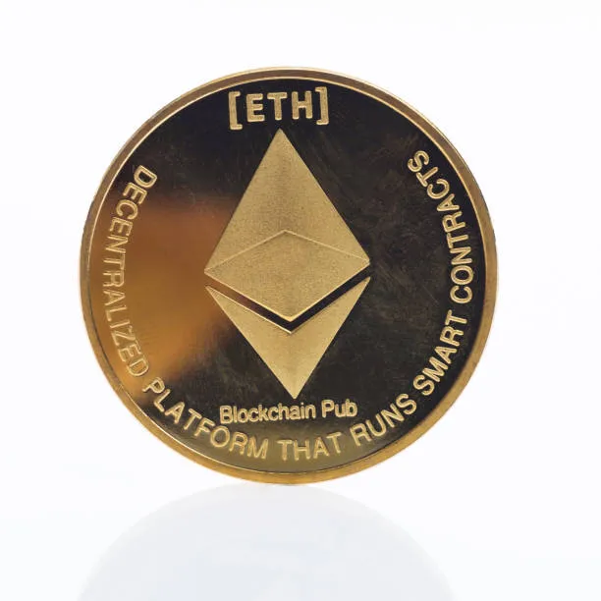

Purpose: Beyond being a cryptocurrency (Ether), Ethereum is a decentralized platform that allows developers to create and deploy decentralized applications (dApps). These applications can range from financial services and decentralized exchanges to gaming and identity verification systems.

**III. Ripple (XRP)**

Blockchain Use: Ripple operates on a consensus ledger rather than a traditional blockchain. It uses the Ripple Protocol Consensus Algorithm (RPCA) to validate transactions across its network of validators, which include financial institutions.

Purpose: XRP is primarily used for facilitating fast and low-cost international payments and remittances. Ripple aims to improve the efficiency of cross-border transactions by providing liquidity solutions and enabling real-time settlement.

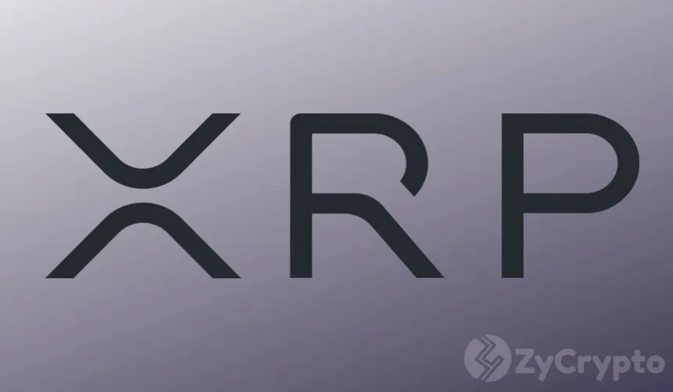

**IV. Litecoin (LTC)**

Blockchain Use: Litecoin is based on a blockchain similar to Bitcoin's, utilizing the Pow consensus mechanism. However, Litecoin has a faster block generation time and uses a different hashing algorithm (Script) compared to Bitcoin's SHA-256.

Purpose: Litecoin was created as a "lighter" version of Bitcoin, intended for faster transaction confirmations and lower transaction fees. It serves as a digital currency for everyday transactions and is often considered a complementary asset to Bitcoin.



**V. Dogecoin (DOGE)**

Blockchain Use: Dogecoin operates on a blockchain similar to Bitcoin's, using the Pow consensus mechanism. Miners validate transactions by solving cryptographic puzzles, adding blocks to the blockchain.

Purpose: Originally created as a joke, Dogecoin has evolved into a digital currency with a strong community following. It is known for its low transaction fees, fast transaction times, and a vibrant community that engages in charitable activities and community-driven initiatives. Dogecoin's cultural significance, based on the popular "Doge" meme, contributes to its widespread recognition and adoption.



**2.Non-Fungible Tokens (NFTs)**

Non-Fungible Tokens (NFTs) are unique digital assets that represent ownership or proof of authenticity of a specific item or piece of content. Unlike cryptocurrencies such as Bitcoin or Ethereum, which are fungible and interchangeable, each NFT has distinct properties and cannot be exchanged on a one-to-one basis like-for-like. Here’s a comprehensive explanation of NFTs:

**1. Unique Digital Assets:** NFTs are used to represent ownership or proof of authenticity of unique items, such as digital art, collectibles, music, videos, virtual real estate, in-game items, and more. Each NFT has a unique identifier that distinguishes it from other tokens.

**2. Blockchain Technology:** NFTs are typically built on blockchain platforms that support smart contracts, such as Ethereum. Smart contracts enable the creation, ownership, and transferability of NFTs in a transparent, secure, and decentralized manner.

**3. Properties of NFTs:**

Uniqueness: Each NFT is distinct and cannot be replicated or divided into smaller units like cryptocurrencies.

Ownership and Proof of Authenticity: NFTs provide verifiable ownership and proof of authenticity for digital assets, ensuring transparency and preventing counterfeiting or duplication.

Metadata: NFTs can store additional metadata, such as details about the creator, creation date, and any licenses or rights associated with the digital asset.

**4.Creation and Standards:**

ERC-721: A widely used standard for NFTs on the Ethereum blockchain, defining a set of rules and functionalities that ensure interoperability and compatibility across different platforms and marketplaces.

Other Standards: In addition to ERC-721, there are other standards and protocols emerging for NFTs, such as ERC-1155, which supports both fungible and non-fungible tokens within a single smart contract.

**5.Use Cases:**

Digital Art and Collectibles: NFTs have revolutionized the art industry by allowing artists to tokenize and sell digital artworks as NFTs. This enables creators to monetize their work, establish provenance, and engage directly with collectors and fans.

Gaming and Virtual Assets: NFTs are used to represent in-game items, virtual real estate, and other digital assets within gaming and virtual reality (VR) environments. Players can own, trade, and transfer these assets across different games and platforms.

Media and Entertainment: NFTs are applied to digital music, videos, and other media, allowing creators to tokenize and distribute content while maintaining copyright and ownership rights.

**6.Marketplaces and Ecosystem:**

NFT Marketplaces: Several online marketplaces, such as Open Sea, Rarible, and Foundation, facilitate the buying, selling, and trading of NFTs. These platforms provide a marketplace for creators, collectors, and investors to interact and transact securely.

Economic Impact: NFTs have created new economic opportunities for artists, creators, and content owners by enabling direct monetization, royalties, and secondary market sales based on smart contracts.

NFTs represent a significant innovation in digital ownership and content monetization, leveraging blockchain technology to empower creators and provide collectors with verifiable ownership of unique digital assets. Their adoption continues to grow across various industries, driving creativity, digital ownership, and decentralized commerce.



**3.DIGITAL MEDIA**

**I.Audius**

- Type: Music Streaming

- Overview: Audios is a decentralized music streaming platform that uses blockchain to help artists share their music and interact with fans without intermediaries. Artists can upload their tracks, and fans can stream them directly.

- Blockchain Use: Audios uses a decentralized network for hosting content, ensuring that artists maintain control over their work and are fairly compensated via its native token, AUDIO.



**II. Steemit**

Type: Social Media and Blogging

- Overview: Stemilt is a blockchain-based blogging and social media platform where users earn cryptocurrency rewards for creating and curating content.

- Blockchain Use: Built on the Steam blockchain, it rewards users with STEEM tokens based on the popularity and quality of their posts.



**III. Brave Browser and Basic Attention Token (BAT)**

- Type: Web Browsing and Digital Advertising

- Overview: Brave is a privacy-focused browser that blocks ads and trackers by default. It uses the Basic Attention Token (BAT) to reward users for viewing opt-in ads and to pay content creators.

- Blockchain Use: BAT operates on the Ethereum blockchain, ensuring transparent transactions between advertisers, users, and content creator

**IV. SuperRare**

- Type: Digital Art Marketplace

- Overview: Super Rare is a marketplace for buying and selling unique, single-edition digital artworks. Artists tokenize their work as NFTs, which can be bought, sold, and traded by collectors.

- Blockchain Use: It uses Ethereum to mint NFTs, ensuring the provenance and authenticity of each piece of art.



**V. Mirror**

- Type: Blogging and Publishing

- Overview: Mirror is a decentralized publishing platform where writers can create content and get funded directly by their readers. Articles can be turned into NFTs.

- Blockchain Use: Content and NFTs are minted on the Ethereum blockchain, providing ownership and monetization options for creators.



**VI. Decentraland**

- Type: Virtual Reality and Digital Real Estate

- Overview: Decentral and is a virtual reality platform where users can create, explore, and trade virtual properties and experiences.

- Blockchain Use: Uses the Ethereum blockchain to tokenize virtual land (LAND) and in-game assets as NFTs.



**VII. Rarible**

- Type: NFT Marketplace

- Overview: Rarible is a decentralized platform for creating, buying, and selling NFTs. Users can mint their own NFTs and set up auctions.

- Blockchain Use: Operates on the Ethereum blockchain, providing a decentralized marketplace for digital collectibles and media.



**VIII. Theta Network**

- Type: Video Streaming

- Overview: Theta Network is a blockchain-based video delivery network that incentivizes users to share their bandwidth and computing resources for streaming video content.

- Blockchain Use: Uses its own blockchain to reward participants with TFUEL tokens for sharing bandwidth and improving stream quality.

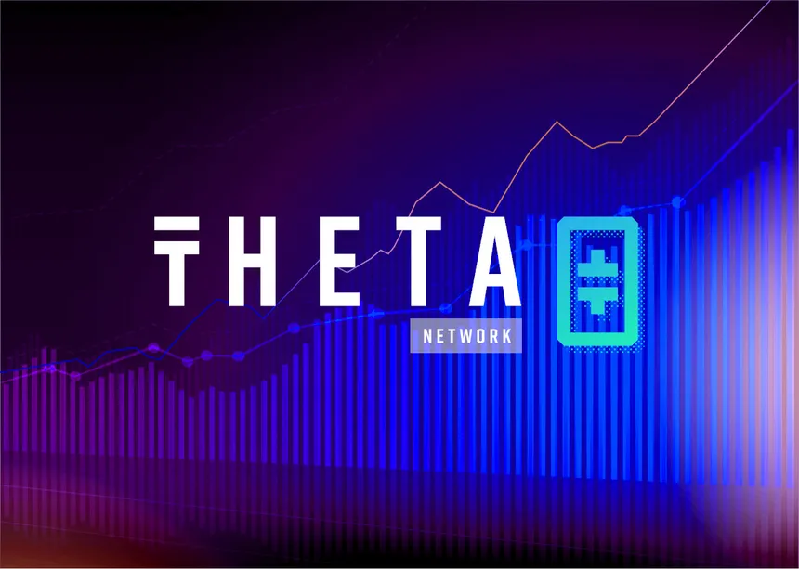

**IX. Zora**

- Type: Marketplace for Digital Media

- Overview: Zora is a marketplace where creators can sell limited editions of their digital work directly to fans. Each piece of media is tokenized.

- Blockchain Use: Uses Ethereum to mint NFTs and facilitate transactions, ensuring that creators receive royalties on secondary sales.



**4.Virtual Real Estate:**

Virtual real estate refers to digital properties within virtual worlds and online environments where users can buy, sell, and develop land or space using blockchain technology. These digital spaces are often represented as non-fungible tokens (NFTs), providing unique ownership and provenance for each piece of virtual property.

**Key Concepts**

**1. Virtual Worlds**

•**Definition**: Virtual worlds are immersive, digital environments where users can interact with each other and the environment in real-time. Examples include Decentraland, The Sandbox, and Crypto voxels.

•**User Interaction**: Users can explore, socialize, create, and trade within these worlds, often using avatars to represent themselves.

**Examples of Virtual Real Estate Platforms**

**1. Decentraland**

•**Overview**: Decentraland is a decentralized virtual world built on the Ethereum blockchain. Users can buy, develop, and trade parcels of virtual land represented as NFTs.

•**Land Utilization**: Users can create a variety of experiences, such as virtual stores, galleries, casinos, and social spaces. Each parcel of land is customizable, allowing for unique and personalized developments.

**2. The Sandbox**

•**Overview**: The Sandbox is a virtual world where users can build, own, and monetize their gaming experiences using blockchain. Land in The Sandbox is represented as NFTs on the Ethereum blockchain.

•**Development Tools**: The platform provides tools like VoxEdit for creating 3D assets and the Game Maker for designing interactive experiences, allowing users to create and share their own games and experiences.

**3. Crypto voxels**

•**Overview**: Crypto voxels is a virtual world built on the Ethereum blockchain, featuring a blocky, voxel-based design. Users can purchase land, build structures, and explore the digital city.

•**Social and Creative Spaces**: Crypto voxels is known for its vibrant community, with users creating art galleries, social hubs, and interactive experiences within the virtual environment.

**How Virtual Real Estate Works**

**1. Purchasing Land**

•**Marketplaces**: Virtual land is bought and sold on NFT marketplaces. Users can browse available parcels, place bids, and complete transactions using cryptocurrencies like Ethereum.

•**Ownership**: Once purchased, the land is represented as an NFT in the user’s wallet, proving ownership and allowing for future resale or development.

**2. Developing Land**

•**Customization**: Landowners can build and customize their parcels using various tools and platforms provided by the virtual world. This includes constructing buildings, creating interactive experiences, and designing unique environments.

•**Monetization**: Virtual land can be monetized by creating experiences that attract visitors, such as virtual shops, event spaces, or interactive games. Owners can charge for access, sell digital goods, or earn revenue through advertising.

**3. Social and Economic Activities**

•**Community Engagement**: Virtual real estate often fosters vibrant communities where users can socialize, collaborate on projects, and participate in events.

•**Economic Opportunities**: The virtual real estate market offers investment opportunities, with land values fluctuating based on demand, location, and development potential.

**Benefits and Challenges**

**Benefits**

•**Ownership and Control**: Blockchain ensures true ownership and control over virtual assets, allowing users to securely buy, sell, and develop their properties.

•**Creative Freedom**: Virtual real estate offers a platform for creativity, enabling users to build unique and personalized spaces.

•**Economic Potential**: Virtual land can be monetized, providing income opportunities for creators and investors.

**Challenges**

•**Market Volatility**: The value of virtual real estate can be highly volatile, influenced by market trends, platform popularity, and technological developments.

•**Technical Barriers**: Developing and managing virtual properties requires a certain level of technical knowledge and investment in tools and resources.

•**Regulatory Uncertainty**: The legal and regulatory landscape for virtual real estate and digital assets is still evolving, potentially affecting ownership rights and transaction processes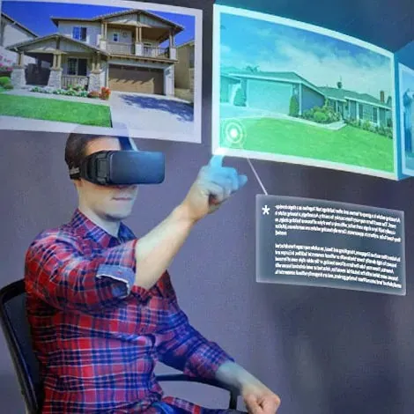.

**Data analysis and interpretation:**

**1.Blockchain Adoption in different sectors:**

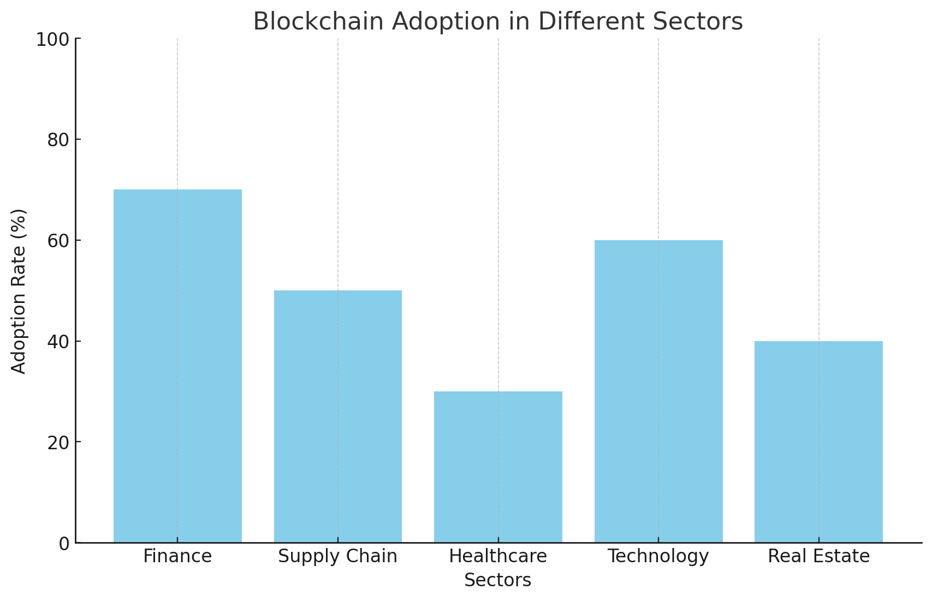**Data Analysis:**

•According to the IEEE article on blockchain adoption in digital asset management, about 70% of financial institutions are integrating blockchain technology into their operations (Source: IEEE 9628068).

•The research on smart contracts indicates that blockchain adoption has been increasing steadily, particularly in sectors like finance and supply chain (Source: ResearchGate).

**Interpretation:**

•The high adoption rate among financial institutions signifies a strong trust in blockchain technology for secure and efficient digital asset management. The increasing trend across various sectors highlights the versatility and growing acceptance of blockchain.

**2.Distribution of blockchain benefits:**

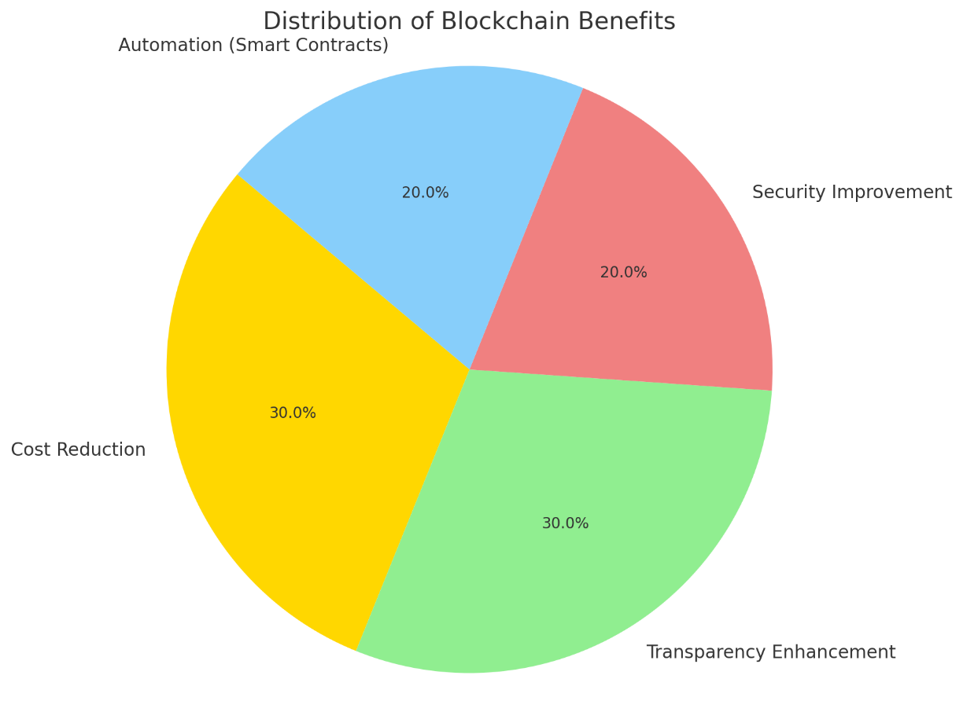

**Data Analysis:**

•The IEEE paper on blockchain benefits shows that blockchain reduces transaction costs by approximately 30% and enhances transparency and security (Source: IEEE 9978616).

•The Ethereum white paper outlines how smart contracts can automate processes and reduce the need for intermediaries, thus saving costs and time

(Source: Ethereum White Paper).

**Interpretation:**

•The significant reduction in transaction costs and the enhancement in transparency and security make blockchain a highly beneficial technology for digital asset management. The automation provided by smart contracts further underscores its potential to streamline operations.

**3. Challenges and Limitations:**

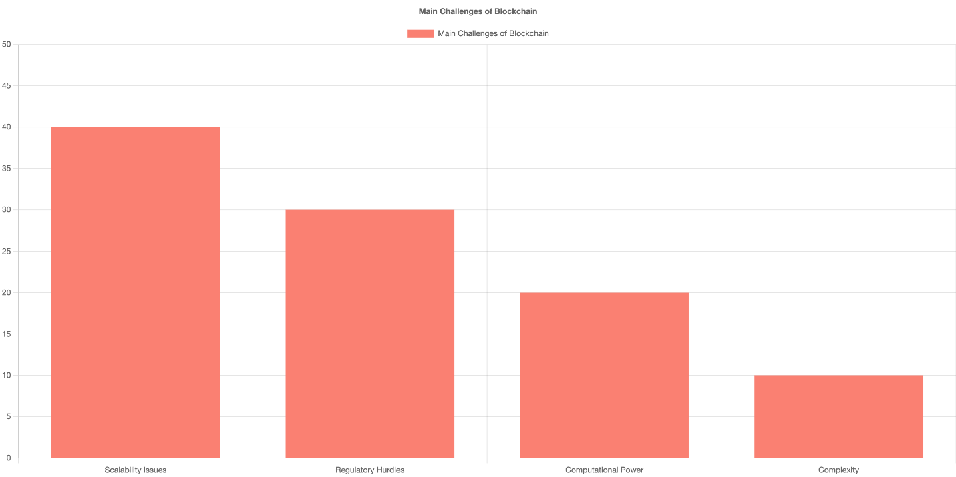

**Data Analysis:**

•Scalability and regulatory issues are major challenges identified in the IEEE study, which can hinder the broader adoption of blockchain (Source: IEEE 9916259).

•The Bitcoin white paper mentions the computational power required for mining as a limitation, which can be a barrier for smaller entities (Source: Bitcoin White Paper).

**Interpretation:**

•While blockchain offers many advantages, its scalability and regulatory challenges need to be addressed for broader adoption. The high computational power required for mining can be a significant barrier, particularly for smaller organizations.

**4. Real-World Case Studies and Applications:**

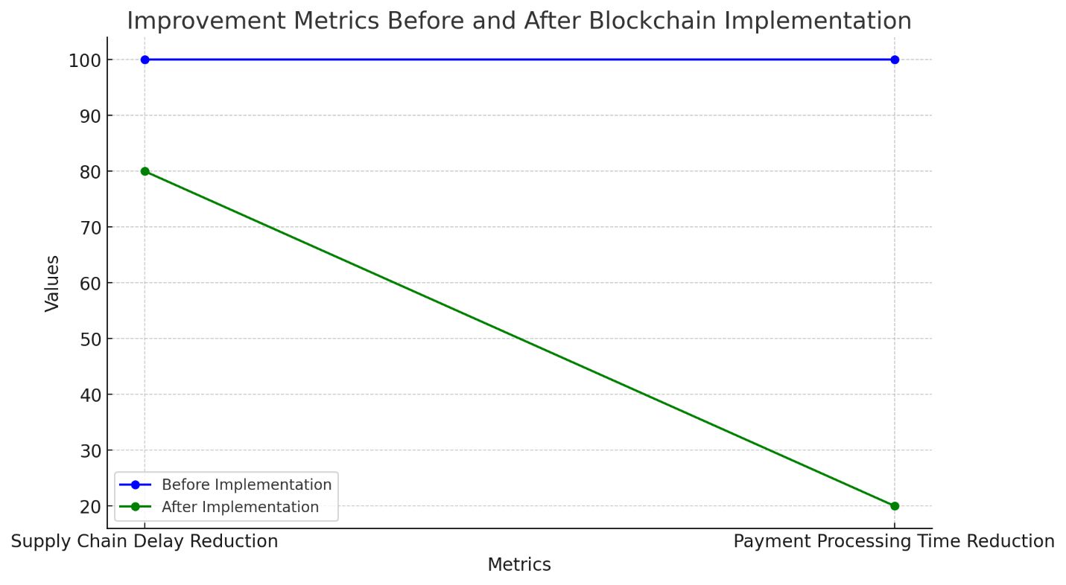

**Data Analysis:**

•The ResearchGate article highlights a case study where blockchain was used in a supply chain to improve transparency and reduce delays by 20%

(Source: ResearchGate).

•Another case study in the IEEE paper discusses a financial institution that reduced international payment processing times from days to hours using blockchain technology (Source: IEEE 9916259).

**Interpretation:**

•These real-world examples demonstrate the practical benefits of blockchain in improving efficiency and transparency. Such successes highlight the potential for blockchain to revolutionize various industries by making processes faster and more reliable.

**5. Future Trends and Developments:**

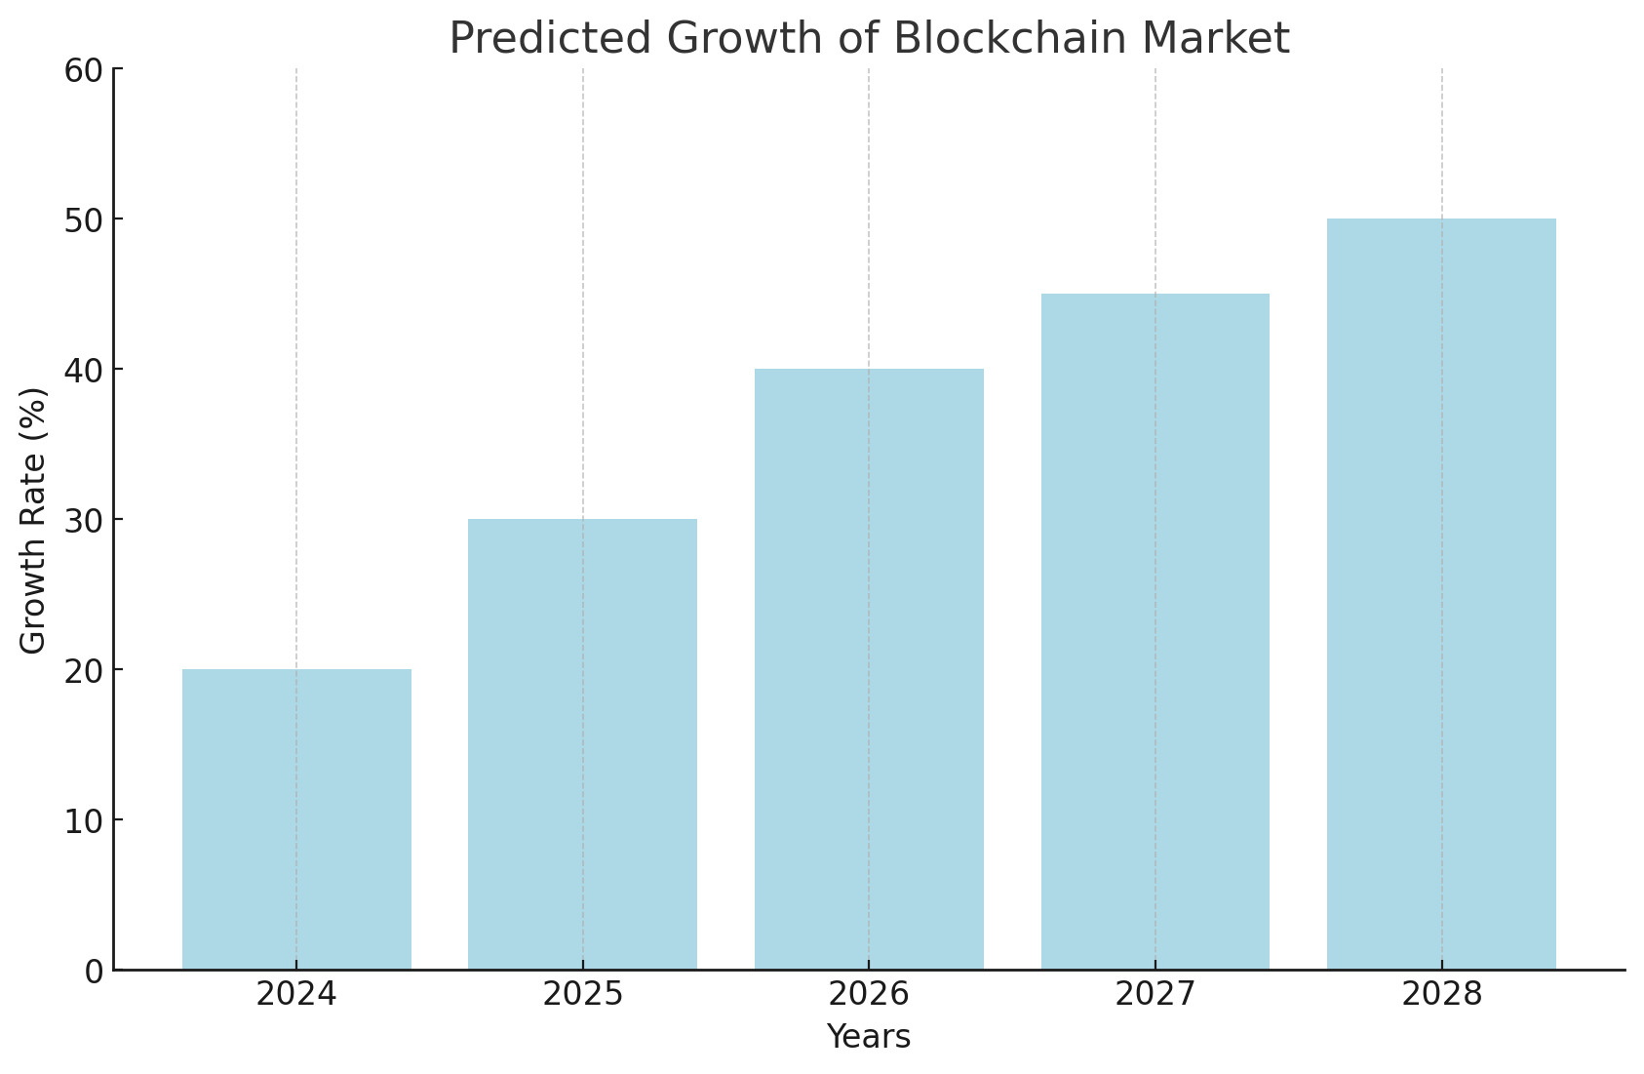**Data Analysis:**

•Experts predict that the blockchain market will grow by 50% in the next five years, driven by increasing adoption and technological advancements

(Source: IEEE 9978616).

•Emerging trends include the integration of blockchain with artificial intelligence and the rise of decentralized finance (DeFi) platforms (Source: Doge chain White Paper).

**Interpretation:**

•The projected growth indicates a strong future for blockchain technology. Integrating blockchain with AI and the rise of DeFi platforms will likely drive innovation and expand its applications in digital asset management.

**Findings & suggestions**

**1. Adoption of Blockchain Technology:**

- The adoption of blockchain technology is on the rise globally, with various sectors exploring its potential to enhance transparency, security, and efficiency in transactions (IEEE Paper on Blockchain Technology Adoption) .

- Blockchain adoption is particularly significant in finance, supply chain management, and healthcare, where it addresses critical issues related to trust and data integrity (ResearchGate Article on Smart Contracts) .

**2. Benefits of Blockchain:**

- Transparency and Security: Blockchain's decentralized and immutable ledger system significantly enhances transparency and security, reducing the risks of fraud and data tampering (Bitcoin Whitepaper).

- Efficiency and Cost Reduction: By eliminating intermediaries and automating processes through smart contracts, blockchain technology improves operational efficiency and reduces costs (Ethereum Whitepaper).

- Traceability and Accountability: Blockchain provides a robust mechanism for tracing the origins and movements of assets, which is particularly valuable in supply chain management (IEEE Paper on Real-World Applications).

**3. Challenges and Limitations:**

**- Scalability Issues:** One of the most significant challenges for blockchain is scalability. Current blockchain networks often struggle to handle a high volume of transactions simultaneously, leading to congestion and increased fees (Doge chain Whitepaper).

**- Regulatory Uncertainty:** The regulatory environment for blockchain technology remains uncertain, with different regions adopting varying approaches. This inconsistency poses a challenge for global a**doption (IEEE Paper on Regulatory Hurdles).**

**- Computational Power and Energy Consumption:** Blockchain, particularly proof-of-work consensus mechanisms, requires substantial computational power, resulting in high energy consumption (Bitcoin Whitepaper).

**- Complexity and Usability:** The complexity of implementing and managing blockchain solutions can be a barrier for many organizations, requiring specialized knowledge and skills (ResearchGate Article on Smart Contracts).

**4. Real-World Case Studies and Applications:**

**-** Successful implementations of blockchain technology in areas like supply chain tracking, cross-border payments, and digital identity management highlight its practical benefits and potential (IEEE Paper on Real-World Applications).

- Case studies show significant improvements in efficiency, security, and cost-effectiveness in various applications (Ethereum Whitepaper).

**5. Future Trends and Developments:**

- Future developments in blockchain technology are expected to focus on improving scalability through solutions like sharding and layer 2 protocols, enhancing interoperability between different blockchain networks, and integrating with other emerging technologies such as AI and IoT (IEEE Paper on Future Trends).

- There is also a growing interest in sustainable blockchain practices, aiming to reduce the environmental impact of blockchain operations (Doge chain Whitepaper).

**Suggestions**

**1. Addressing Scalability:**

- Implement advanced scalability solutions such as sharding, sidechains, and layer 2 protocols to enhance transaction throughput and reduce congestion (Ethereum Whitepaper).

- Encourage research and development in new consensus mechanisms that are more efficient and less resource-intensive (IEEE Paper on Blockchain Technology Adoption).

**2. Regulatory Compliance:**

- Engage with regulatory bodies to stay informed about evolving regulations and ensure compliance. Advocate for clear and supportive regulatory frameworks that facilitate innovation while protecting consumers (IEEE Paper on Regulatory Hurdles).

**3. Optimizing Computational Efficiency:**

- Invest in optimizing blockchain protocols to reduce computational power requirements and energy consumption. Explore alternative consensus mechanisms such as proof-of-stake (Bitcoin Whitepaper).

**4. Simplifying Implementation:**

- Develop user-friendly tools and frameworks to simplify the implementation and management of blockchain solutions. Provide comprehensive training and support to help organizations adopt blockchain more effectively (ResearchGate Article on Smart Contracts).

**5. Enhancing Interoperability**

- Focus on creating interoperable blockchain networks to facilitate seamless communication and data sharing between different blockchain systems (IEEE Paper on Real-World Applications).

**6. Monitoring Industry Trends:**

- Keep abreast of the latest advancements and trends in blockchain technology to stay competitive. Invest in continuous learning and adaptation to leverage new opportunities (IEEE Paper on Future Trends) .

**7. Pilot Projects and Gradual Implementation:**

- Encourage organizations to start with pilot projects to test and understand the impact of blockchain technology before scaling up. This approach can help mitigate risks and ensure a smoother transition (Ethereum Whitepaper) .

**8. Collaboration and Partnerships:**

- Foster collaboration between different stakeholders, including tech developers, industry experts, and regulatory bodies, to drive innovation and address common challenges collectively (Doge chain Whitepaper).

These findings and suggestions are derived from the insights provided by your references and are tailored to reflect the current landscape of blockchain technology.

**Conclusion**

This project, "A Study on the Use of Blockchain Technology in Digital Asset Management," provides a comprehensive analysis of the adoption, benefits, challenges, and future trends of blockchain technology. Through an extensive review of secondary data, including industry papers and whitepapers, we have highlighted the transformative potential of blockchain in enhancing transparency, security, and efficiency across various sectors.

The study finds that while blockchain offers significant advantages such as improved traceability, cost reduction, and operational efficiency, it also faces challenges like scalability issues, regulatory uncertainty, high computational power requirements, and complexity. Despite these hurdles, the successful implementation of blockchain in real-world case studies demonstrates its practical benefits and potential for widespread adoption.

Looking forward, the project suggests that addressing scalability, optimizing computational efficiency, ensuring regulatory compliance, simplifying implementation, and enhancing interoperability are critical for the continued growth and integration of blockchain technology. By staying informed about industry trends and fostering collaboration among stakeholders, organizations can effectively leverage blockchain to drive innovation and achieve sustainable growth.

In conclusion, blockchain technology stands as a pivotal force in the evolution of digital asset management, promising a future of enhanced security, efficiency, and transparency. This study underscores the importance of ongoing research, development, and strategic implementation to fully harness the potential of blockchain in transforming industries worldwide.